Northern Arizona University

PCI Big Beam Contest 2013

Team 1 (XDF)
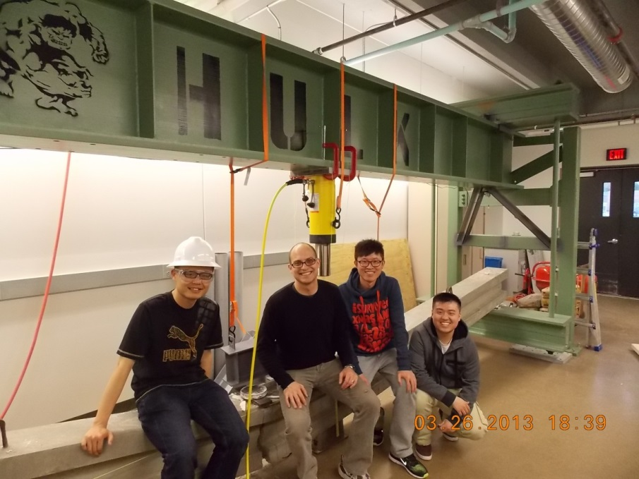
Team Members
Junfeng Qian
Qi Wang
Shiyu Wang
Technical Advisor
Robin Tuchscherer, Ph.D., P.E.
Assistant Professor
Concrete Construction Member Contest Sponsors
Tpac A Division of Kiewit Western Co. Precast/ Prestressed Concrete Institute
Phoenix, AZ Sika Corporation
Special Thanks to David L. Chapin


Table of Contents
1. Introduction 3
2. Background 3
3. Concrete Mix 5
4. Beam Design 7
5. Final Analysis & Prediction 8
6. Test Set Up 12
6.1 Concrete Cylinder Sample Test 12
6.2 Beam Test 12
7. Test Result 14
8. Comparison of Prediction and Test Results 14
9. Conclusion 15
10. Lessons Learned and Suggestions for the Future 15
11. Test Summary Form 17
Appendix A—Reference
Appendix B—Shop Drawing
Appendix C—Photographs of Field Trip
Appendix D—Photographs of Test Machine
Appendix E—Deflection Prediction
Appendix F—Detail of Final Beam Desgin
Appendix G—Response 2000 Analysis
Appendix H—Design Matrix
Appendix I—Test Machine
Appendix J—Photographs of Beam Test
Appendix K—Concrete Mix Report
Appendix L—Final Calculation (Hand Wirting)

Introduction
Team 1 participates in the PCI Big Beam Contest for the 2013-2013 academic years. In order to finish this project, the team design and build a prestressed concrete beam which is 20 ft. long and test as a18 ft. span. The beam has to be designed to meet the contest rules. The team begins to approach this project by reviewing the contest rules and assign tasks to team members. In addition, the team asks Dr. Tuchscherer, who is PCI Big Beam Contest technical advisor, for some suggestions. Based on the information gathered from these resources, the team decides that the central design of this project should include the cross-sectional geometry, the selection of possible mix designs, the size of reinforcing bar and prestressed strand, and location of reinforcing bar and prestressed strand.
This project is a real challenge for the team which is composed of undergraduate students. The team members have limit knowledge of prestressed concrete beam design. Therefore, a background research is necessary for the team to complete before the beam design. During the beam design, the team creates several judging criteria to pick the final design from the design alternatives. The background, mix design, beam design, and final analysis and prediction are described in the following section of this report. A description of the testing process, a discussion of the results, and conclusion are also included.

Background
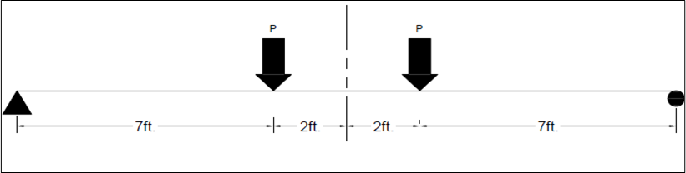
As the contest rule required, the beam should be designed to carry a total factored live load between 32 kips and 39 kips. In addition, the beam shall not crack under the total applied service load of 20 kips. If the beam does not meet these requirements, the scores will decrease. The beam should be loaded by applying two point loads, symmetrically, 7 feet from the center of each support. Figure 1 shows the permitted load configuration that the team used to test the beam. In addition, low cost, low weight, largest measured deflection at midspan, and the predictions of design load, deflection, and cracking load should be put into consideration in order to get a high score.
Figure 1: Permitted Load Configuration
However, based on the understanding of the team, the key criteria that affect our design should be design load, total cost, and weight. Each of them could have a big effect on the design of the beam. The unit cost of materials that used in beam design is regulated in the contest rules. Table 1 shows the unit cost of each material.
Table 1: Unit Cost of Material
Material | Cost
Concrete | $100/yd³
Fiber-Strength Concrete | $120/yd³
Fiber-Reinforced Concrete | $110/yd3
Lightweight Concrete | add $10/yd³ to the concrete cost
Prestressing Strand:
3/8 in. Diameter | $0.17/ft.
1/2 in. diameter | $0.30/ft.
1/3 in. diameter | $0.32/ft.
0.6 in. diameter | $0.42/ft.
0.7 in. diameter | $0.55/ft.
Steel:
A615/A706 | $0.45/lb.
Weld wire | $0.50/lb.
A1035 | $0.70/lb.
Plate steel | $0.55/lb.

The information of the concrete mix is given by the sponsor company, Tpac Company. A field trip visit to the Tpac Company gives the team a lot of information about fabrication of concrete beam. Figure 2 shows the trademark of Tpac Company. The project manager David L. Chapin of Sponsor Company provides the limitation of strand spacing to 2 inches and the availability of ½ -inch “special” strands. Only #4 and #5 of A615 steel could be used in beam design. For the final design of the beam, the team decides to use self-consolidating concrete which have a 4500 psi specified compressive strength of concrete at the time of initial prestress (f’ci=4500 psi) and a 8500 psi specified compressive strength of concrete (f’c=8500 psi). In addition, ASTM Seven-Wire Strand (Grade 270), and ASTM A615/A706 (#5 rebar) are used in the beam design. The selection of concrete mix, reinforcing bar, and prestressed strand are explained in the upcoming sections.
Figure 2: Field Trip to Tpac Company in Phoenix


Figure 2: Field Trip to Tpac Company in Phoenix

Concrete Mix
The materials for the mix design were determined by availability. Due to the requirement of Tpac Company, the concrete material could be selected from lightweight concrete and normal weight concrete (self-consolidated concrete). Before the decision is rendered, the team creates a table to compare lightweight concrete and self-consolidating concrete. Table 2 shows the pros and cons of each concrete.

Table 2: Pros and Cons of Self-Consolidating Concrete and Lightweight Concrete
 | Self-Consolidating Concrete | Lightweight Concrete
Pros | - Easy to achieve high strength transfer and ultimate.  - Low Water Cement ratio assists with permeability.  - Easy to place concrete with maximum consolidation.  - Proven Performance.  - High shear values at transfer and 28 days. | - Low unit weight  - Good to above average 28 day compression strength for lightweight.  - Low Water Cement ratio assists with permeability.  - Easy to place concrete with maximum consolidation.  - High fire rating.
Cons | - High unit weight.  - No air entrainment for severe weather conditions.  - Low fire rating. | - Low shear values at transfer and 28 days.  - Specific gravity of lightweight material is unstable.  - Low transfer strengths if proper curing procedures are not used.

As can be seen from Table 1, both self-consolidating concrete and lightweight concrete have advantages and disadvantages. Based on our understanding of this project, a stable performance, great compressive force, and high shear values are more important for the beam to meet all the contest rules. Self-consolidating concrete has a proven performance and it is easy to achieve high strength transfer and ultimate. Additionally, cost is another important factor that the team put into consideration. From the unit cost table (Figure 2), normal weight concrete (self-consolidating concrete) is $10 cheaper than lightweight concrete per cubic yard. Therefore, the team worked with Tpac Company to choose the concrete mix, using a 28-day compressive strength of 8,500 psi.
The concrete mix design data is provided by Tpac Company. The proportions and measured weight of concrete mix is shown in Table 3.
Table 3: Final Concrete Mix*
Material | Material Weight
Type II APC (Cement) | 655 lb
Class F (fly ash) | 240 lb
Aggregate: WCS Maricopa | 1300 lb
Aggregate: ½” No.7 Rock | 1399 lb
Water | 325 lb
Estimate Air | 1.00%
*Chemical admixtures are not listed as they are proprietary
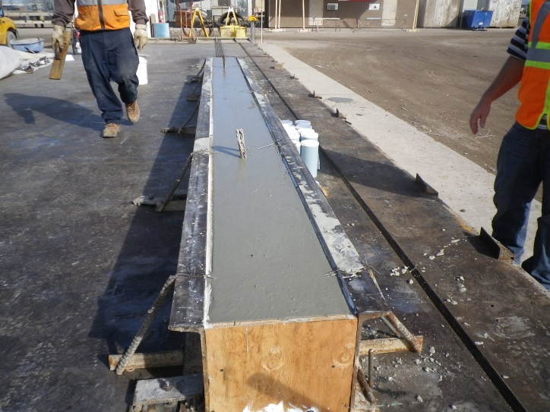
The mixes use Type II cement and a water-to-cement ratio of 0.363 to achieve high strengths. Fly ash is used to increase the strength of the mix while also decreasing the water demand. Figure 3 shows the scene of beam fabrication.
Figure 3: Concrete Fabrication

Beam Design
Considering the construct convenient and efficiency, “I” shape is used to design the beam. Because I shape has less weight, less materials used, and higher strength comparing to the other same level shapes, such as T shape beam and box shape beam. In order to perform well in each of the judging criterion and satisfy the provision of ACI-318 code and the PCI Design Handbook, firstly Team 1 used excel sheet to meet all requirements of the contest, such as cracking moment, stress at release, and design load. After meet all the requirements, Team 1 tried eight alternatives based on “I” shape by changing the dimension of cross-section of the beam, number of strand, and number of reinforcement bar to reduce the cost and the weight. As the table shown below, Team 1 takes three types of I shape beams to as the final comparison to each other. Table 4 shows comparison of three qualified design options.
Table 4: Three Qualified Design Options with Several Key Variables
 |  |  |  | Release Stress |  | Live Load |  | ∆ Equiv
Cross Section | f'_{c} (ksi) | f'_{ci} (ksi) | # of strands | σ_{top} (ksi) | σ _{bot} (ksi) | P crack (kip) | PU (kip) | EI (kip-in²)
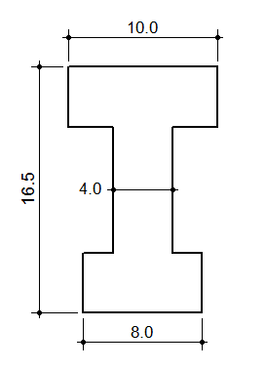 | 8.5 | 4.5 | 3 | 0.365 | -2.198 | 23.8 | 33.6 | 61766449
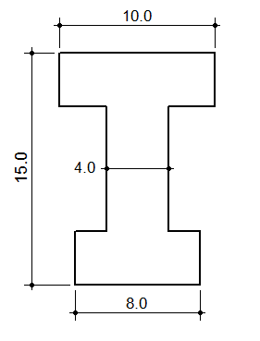 | 8.5 | 4.5 | 4 | 0.517 | -3.037 | 34.4 | 36.8 | 65442229
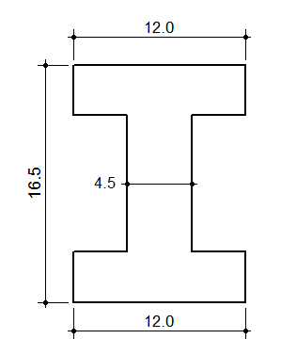 | 8.5 | 4.5 | 4 | 0.356 | -2.157 | 29.8 | 40.78 | 68335328
Requirement |  |  |  | σ_{top}<$7.5\sqrt{f'c }$ | σ _{bot}<0.7 f'_{ci} | P>20 kips | 32 <P<39 (kips)

As the table shows, all of the three type of I shape beams meet the requirements of the contest. In order to determine the most efficient design, Team 1 did design matrix of the three different designs of concrete. The elevation view of the beam design is shown in Figure 2. This final design satisfies ACI-318 tensile and compressive stress checks at release and under service load. Table 5 shows the design matrix.

Table 5: Design Matrix
 |  | Beam 1 |  | Beam 2 |  | Beam 3
Type | Percentile | Measured Value | Grade | Measured Value | Grade | Measured Value | Grade
Cost ($) | 35 | 126.5 | 10 | 132.5 | 9 | 142.5 | 7
EI* (kip-in2) | 30 | 61766449 | 8 | 65442229 | 9 | 68335328 | 7
Weight (lb.) | 35 | 1909.59 | 10 | 1900.06 | 10 | 1990.31 | 6
Total (10) | 100 |  | 9.4 |  | 9.35 |  | 6.65
*EI= Flexural Stiffness; the lower the EI, the higher the deflection
As the table shown above, “Beam 1” gets the highest score of the three designs. As a result, team 1 chose this beam design as their final beam design. Figure 4 shows the detail of cross-section of final design.
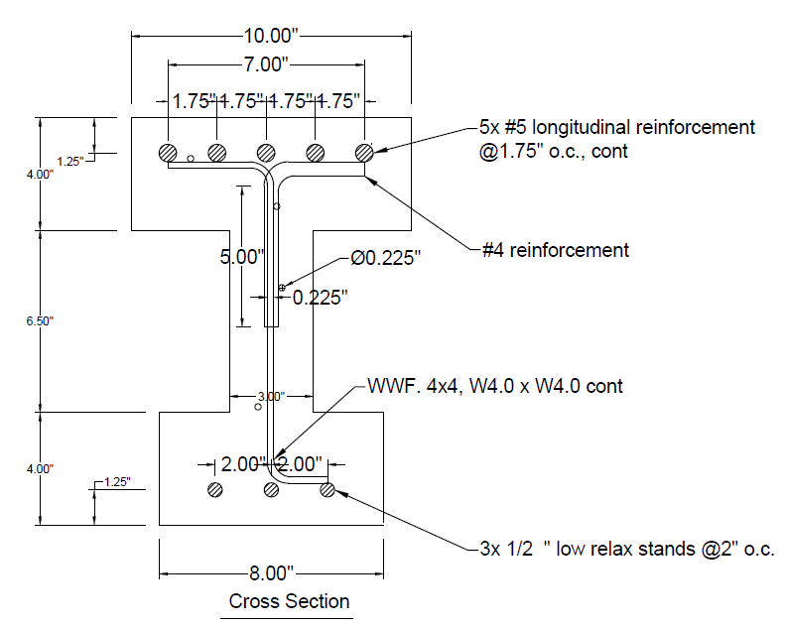
Figure 3: Cross-Section of Final Design
As the details shows in Figure 4, the team uses 5 A615 steels (NO.5), 3 prestressing strands, and A615 steel (NO.4) in the final design. The amount and cost of each material are list in Table 6.
Table 6: Detail of Materials used in Final Design
Materials | Amount | Unit Cost | Cost
Normal Weight Concrete | 0.47 cu yd. | $ 100/cu yd. | $ 47
Prestressing Strand | 3*20 ft. | $ 0.30/ft. | $ 18
A615 #5 Rebar | 5*20 ft. | $ 0.45/lb. | $ 47
Welded Mesh | 25.8 lb. | $ 0.50/lb. | $ 13
A615 #4 Rebar | 4*0.7 ft. | $ 0.45/lb. | $1.5
Total Cost | $ 126.5

Final Analysis & Prediction
Predicted values of stress at release, cracking moment, moment capacity, design load, and shear capacity are done by using Excel software and the calculations are checked by hand. The Tpac Company did the most part of the fabrication process for the team. Tpac Company provided concrete mix, formwork, longitudinal reinforcement, and tendons to the team. Response 2000 software is used to perform refined analysis which can generate more accurately predict strength and deflection values. As the final analysis show, the response values are fairly close to the Excel values. Figure 5 shows the moment curvature.
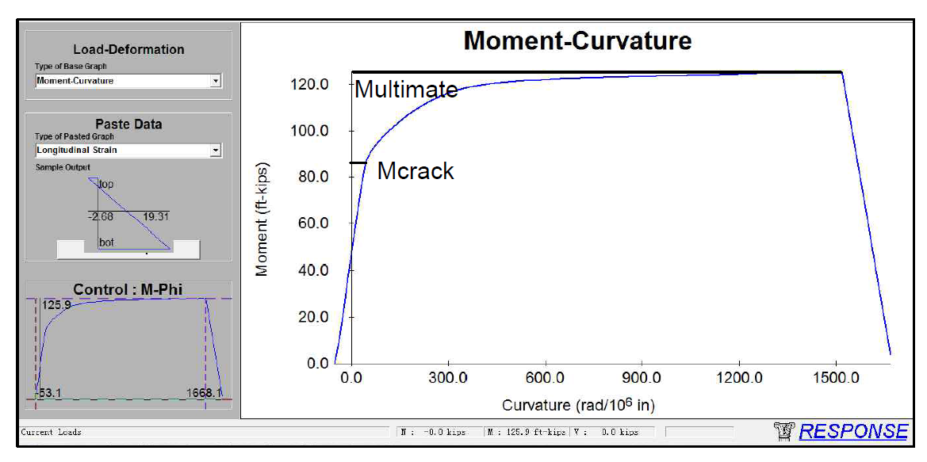
Figure 5: Moment Curvature from Response 2000
After getting the Moment-Curvature response, the team used the method of virtual work to predict the deflection of the beam. The equation of the virtual-work method is
$∆=\int_{0}^{l}{\frac{m_{p}m_{Q}}{EI}}dx+\int_{0}^{l}{k\frac{V_{p}V_{Q}}{GA}dx}$.
In this equation, “m_{Q}” is virtual moment produced by virtual moment; “m_{p}” is real moment; “E” is the modulus of elasticity. “I” is the moment of inertia. “V_{p}” is real shear force; “V_{Q}” is shear force produced by virtual load.
Figure 6 shows how the loaded distributed on the beam. The distribution load is the dead load of the beam, and the concentrated load is the load come from the hydraulic cylinder.

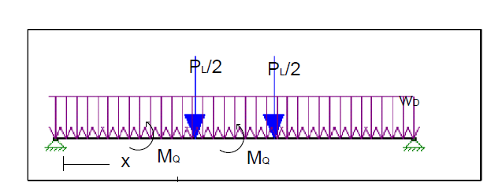
The moment equation of the beam is shown below:
Figure 6: Load Distribution Diagram
When 0<x<7 M_{Q}(x) = (ω (9’) +P_{n}) x-$\frac{wdlx^{2}}{2}$
When 7<x<9 M_{Q}(x) = (ω (9’) +P_{n}) x-$\frac{wdlx^{2}}{2}-Pu(x-7)$
By using excel sheet, the prediction of the deflection is 1.7 ft. Figure 7 shows the Microsoft Excel spreadsheet which is used to predict the deflection of the final design.

Figure 7: Excel Spreadsheet for Beam Deflection

After determining the final design of concrete beam, the team sent the final design to Tpac Company for fabrication. On February 8, 2013, prestressed concrete beams were fabricated at Tpac Company.

Test Set Up
In Test section, it will address concrete cylinder test and beam test. Cylinder test is to achieve more accurate value of the modulus of elasticity of concrete, which in turn reduce differences between theoretical prediction and actual test result. Beam test is a primary process in the project. During the beam test, beam will be loaded till to failure to obtain values of cracking load, ultimate load and deflection.

Concrete Cylinder Sample Test
Concrete cylinder sample test was test one day before the beam test. Six 4X8 cylinders were available to be tested, three of them were conducted by compression test and the other three were conducted by split cylinder test. The compression test and split tension test were both conducted with universal testing machine at mechanical material laboratory.
By doing the concrete cylinder sample test, results were recorded in Table 7:
Table 7: Cylinder Sample Test Results
Average calculated compressive pressure (psi) | Average splitting tensile strength  (psi)
8316 | 541

Beam Test
The prestressed concrete beam was tested in the Concrete Lab in Engineering Building at Northern Arizona University on March 26th, 48 days after the beam was cast at Tpac Company. Before the test, one beam picture with March 26th newspaper was taken and sent to the Sponsor Dave to show that the beam was taken on or after March 26th, The basic information of Team 1 prestressed concrete beam and the prediction of applied point load at midspan to cause cracking, maximum applied point load at midspan, and maximum anticipated deflection due to applied load only were sent to Dave via email as well before the beam test (for more information, please see the appendix). The Entire process of the beam test was recorded by video. Weight of the beam has been measured by Tpac Company. The weight of the beam is 2,000lb. Before testing, Team 1 has ensured that the beam rested evenly on the test machine.
The test instrument can be illustrated by Figure 8: 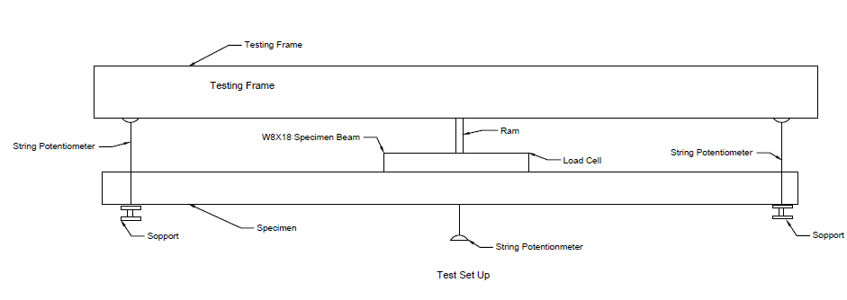
Figure 8: Test Instrument
As Figure 8 shows, the span length between the two pads is 18ft. The ram is located in the center of the beam. The two load points are 7 ft. away from the center of the beam.
During the test, all the data, such as deflection and load was collected by using computer software. The String Potentiometer transfers the deflection of the beam into the computer software. The load was increased by approximately 10 kip increments until 20 kip. After the point of 20 kips, the load was increased slowly so that the more accurate date can be achieved. After every load increment, Team 1 needed to read the deflection and inspect the crack whether the beam has cracked personally.
When the load came to the maximum load that the beam could hold, a lot of crackles came out from the side to the midspan. Some cracks had an angle of 45º to the midspan. The failure happened when the load came to 41.54 kips. The failure point was on the right side load point of the beam 4 ft. away from the midspan.

Test Result
All the test results were recorded by using computer software. All the data from the strain gauges were in electricity and Team 1 transferred it into data by multiplying the string factor. After getting the data, these data was input into excel sheet to do the comparison to the prediction. Applied point load at midspan to cause cracking is 23.2kip. The maximum applied point load at midspan is 41.54 kip. Maximum anticipated deflection due to applied load only is 7.42 in. Figure 9 shows the load-deflection curve.
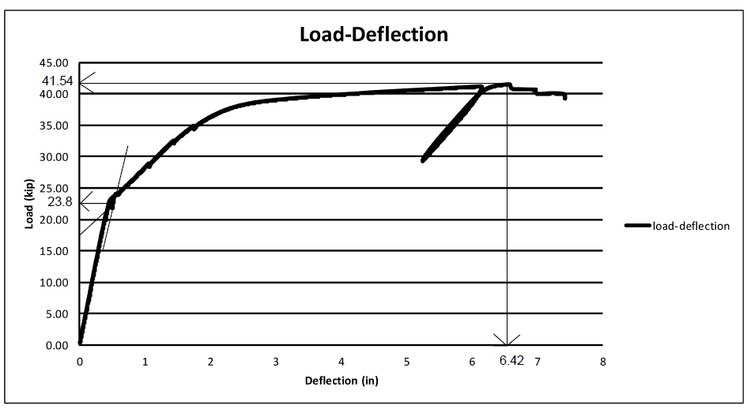
Figure 9 Deflection of the Beam with Increasing the Load

Comparison of Prediction and Test Results
The performance of the concrete beam was well predicted by Team 1. As expected, the prestressed concrete was failure duo to the ultimate load. As anticipated, when going to failure, the stress and strain curve came to near a horizontal line, then drop slightly to the failure point. The table below shows the comparison between prediction and test results. The prediction of point load at crack is pretty close to the actual value. However, the maximum applied point load at midspan and the maximum anticipated deflection due to applied load are no as accurate as crack load. The operation of increment of load may cause the error as well. Table 8 shows the predicted and actual values of the beam with percent errors. In addition, the reason that the deflection has such a huge difference between the prediction value and the actual value is that the team did not change the default value of peak strain in Response 2000 computer software. This mistake made a huge difference in the deflection.

Table 8: Predicted Values VS. Actual Values
Data Description | Predicted | Actual | Percent Error
Point Load Cracking (kips) | 23.8 | 23.2 | 2.52%
Maximum Point Load (kips) | 36.35 | 41.54 | 14.3%
Deflection at Maximum Load (in) | 1.703 | 6.42 | 335.7%

Conclusion
In order to meet the design criteria presented in the 2013 PCI Big Beam Contest, the team learn the knowledge from all kinds of sources about prestressed concrete and contribute to beam design. During the beam design, the team makes a lot of changes on the original design to meet the design restriction and satisfy ACI and PCI provisions. The beam is fabricated by the sponsor company-Tpac. Therefore, the materials used in the design are limited. However, the use of wired mesh is the most noticeable feature. The wired mesh resulted in increase the shear capacity of the prestressed concrete beam and reduces the total weight. Including additional stirrups in the beam was another characteristic. These stirrups are added to ensure the beam does not fail due to shear force and all compression steels are hooked up. The results of ultimate load and deflection have a big differences when compare with the predictions. The main reason that leads to these differences is that the team did not change the default value of peak strain in Responses 2000 program. However, the result of cracking load is very close to what the team predicts. Due to the correct Excel spreadsheet, the team get the accurate value when calculate the cracking load. Ultimately, these design characteristics encompassed an optimized design and a well-understood concrete beam.

Lessons Learned and Suggestions for the Future
Participating in the PCI Big Beam Contest help the team members to enrich the knowledge and improve abilities. During the beam design, the team gets the experience on how to work in a group to study the knowledge of prestressed concrete, computer design, and conduct the beam test. In order to move the project forward smoothly, each teammate is clear on their roles which are assigned at the beginning of the project. The roles include beam designer, project manager, report writer. Each teammate is responsible for a particular project component. When each component is finished, the entire team goes through the whole process of this project. Working on this project in a group not only helps each teammate to increase his abilities of communication, organization, and initiative learning, but also let the teammates recognize their strengths and weakness.
As undergraduate students, it is a challenge for the team to design a prestressed concrete beam. First of all, the team needs to learn the knowledge of prestressed concrete. Then, the team needs to be familiar with ACI-318 code and PCI design handbook in order to meet the design limitations such as stress at release (f_{top}, f_{bottom}). During the beam design, the team use Microsoft Excel to build the dimension of the cross section of the beam and calculate each variable. In order to achieve the goals of lowest weight, lowest cost, largest deflection, and highest maximum load , the team is required to understand the effects of cross section dimension, stirrups, compression steel, prestressed strands, and the location of reinforcement. These individual components have a big effect on the behavior of concrete beam, which means it is necessary for the team to learn these important knowledge and concept during the beam design or even before the project start.
In addition, each teammate learns how to operate a concrete beam test from this project. The process of setting up the test instrument, installing sensors, design the deflection indicator, and finally testing the beam is a good learning experience for the team members. Even though the beam is design to meet the rules and testing criteria assigned in the contest, the knowledge from the experience can be applied to future design problems.
If the team has another opportunity to participate the PCI Big Beam Contest again, the team will be carefully notice the operation of Response 2000 program and ultimate load prediction.

Here are some recommendations from Team 1 for PCI Big Beam Contest:
- A discussion of future application of the beam should be required in the contest rules
- People who have different academic background could participate in this contest
- The contest committee should assign a technical faculty to each team

Test Summary Form
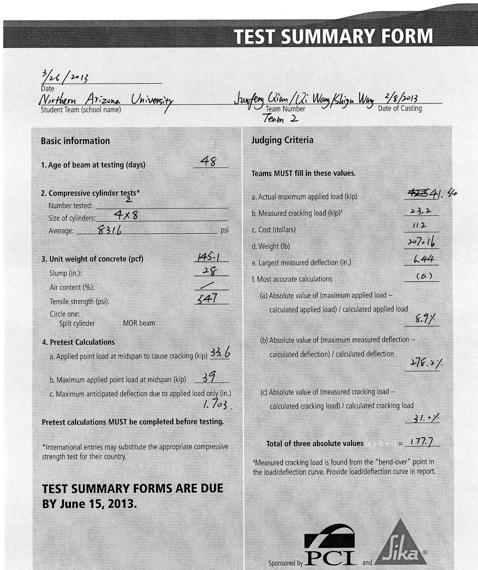

Appendix A— References
ACI (2011). ACI 318-11: Building Code Requirements for Structural Concrete and Commentary.
PCI (2010), PCI Design Handbook, Precast and Prestressed Concrete, Seventh Edition.

Appendix B—Shop Drawing
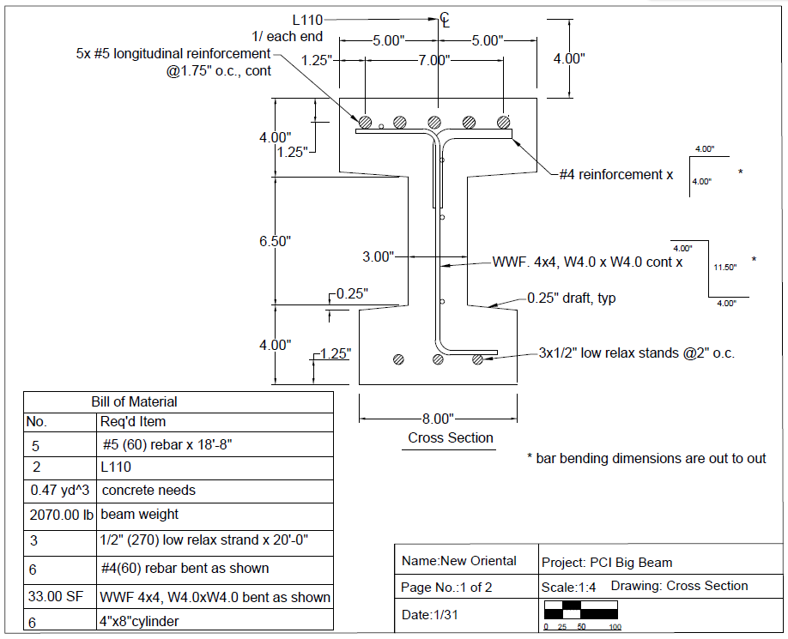
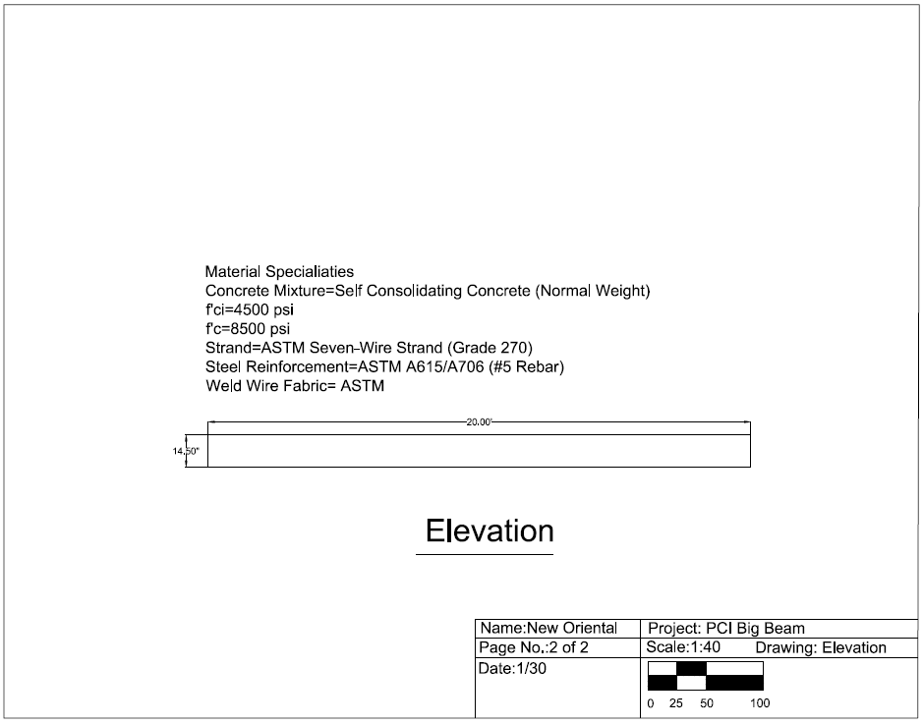

Appendix C— Field Trip Photographs

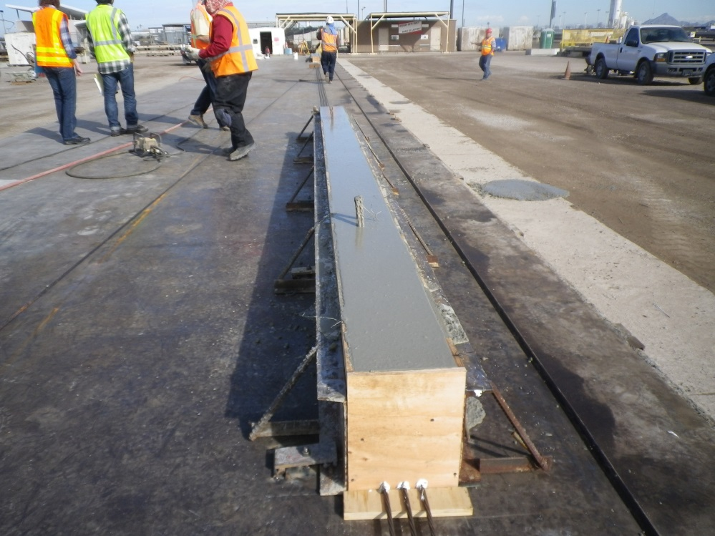

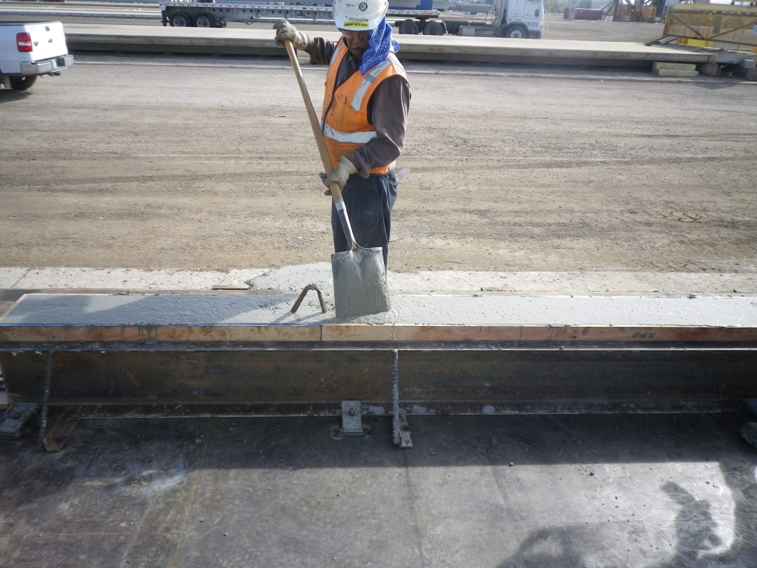
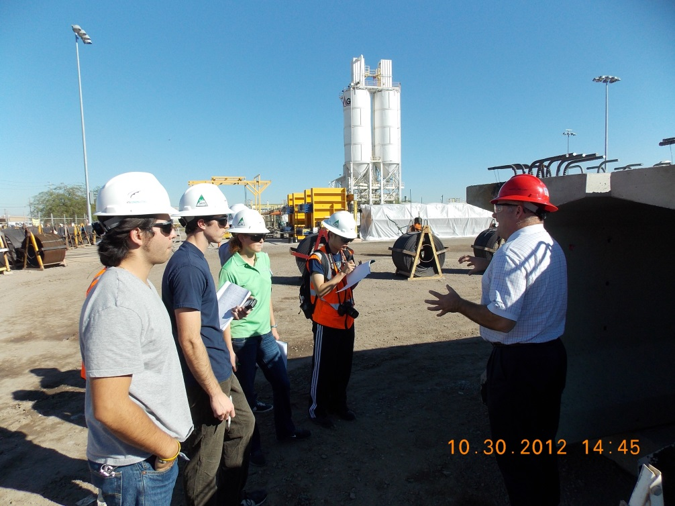

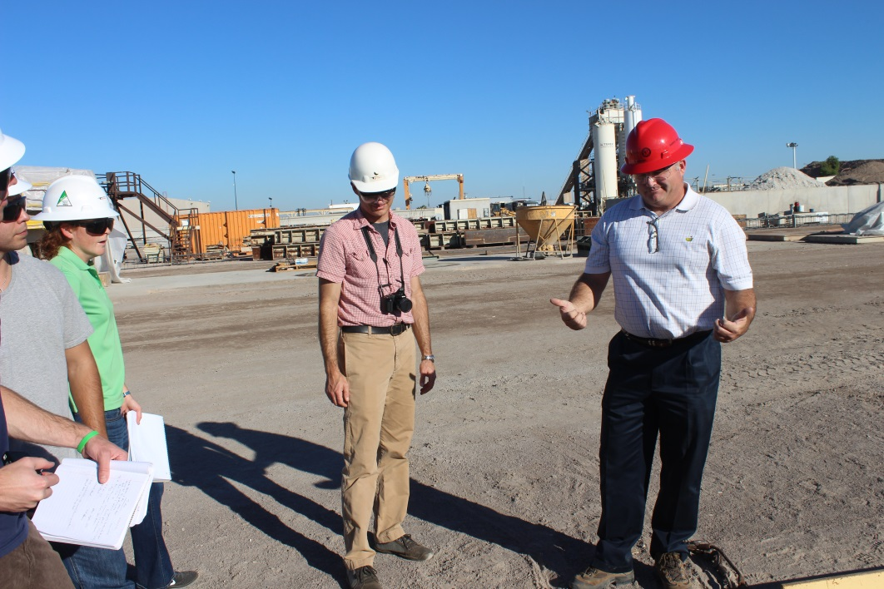

Appendix D—Photographs of Test Machine
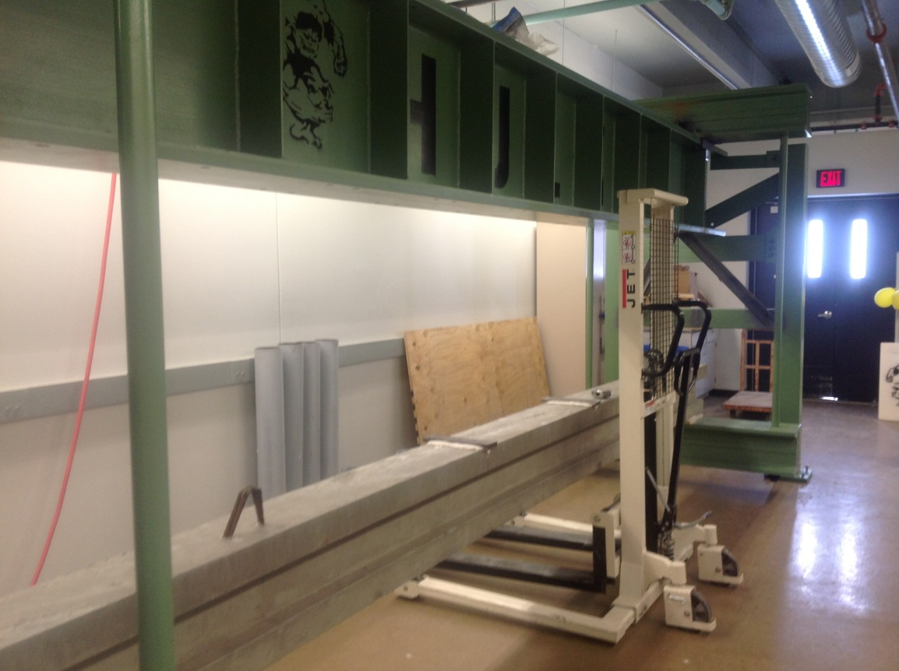
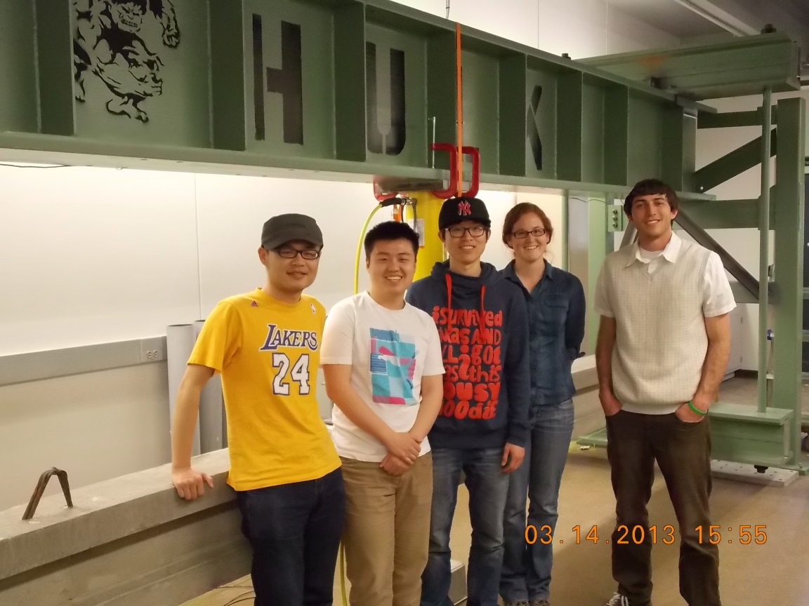

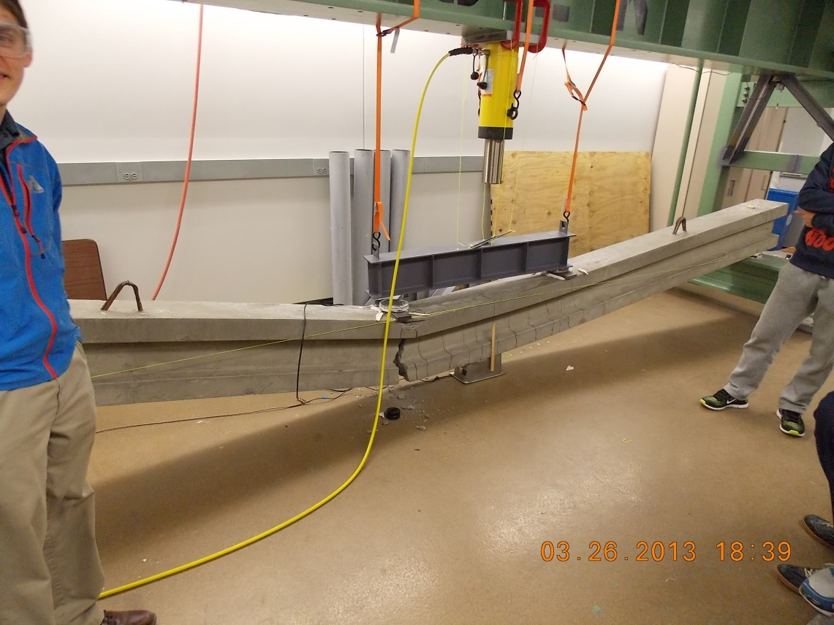

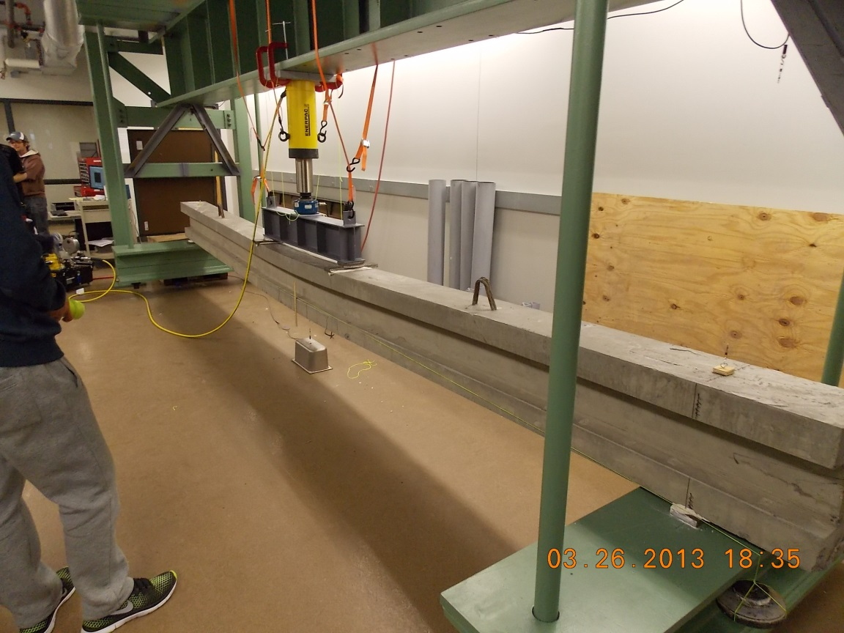
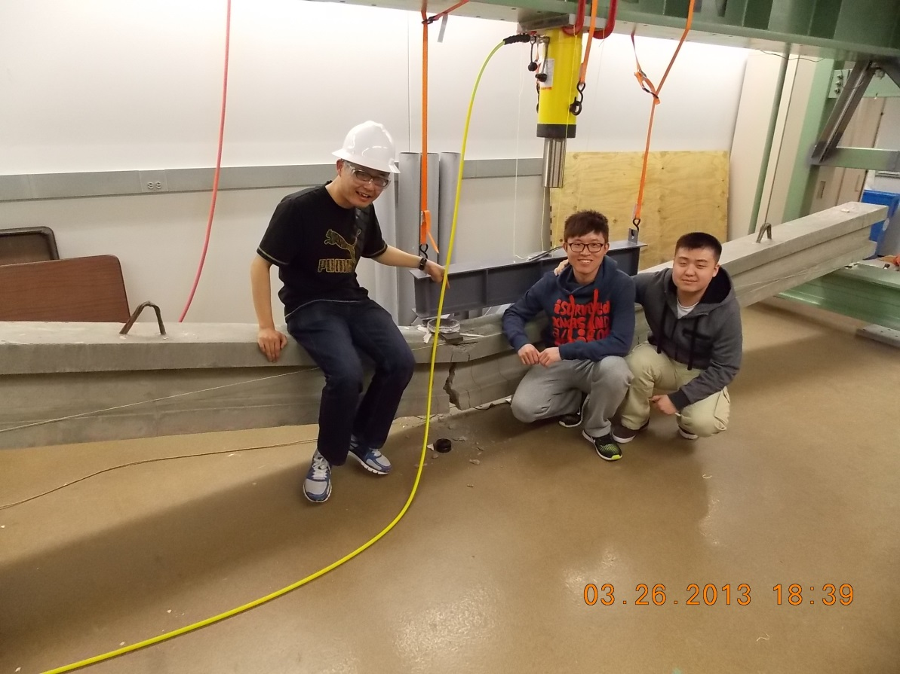

Appendix E —Deflection Prediction

Appendix F—Detail of Final Beam Design

Appendix G —Response 2000 Analysis
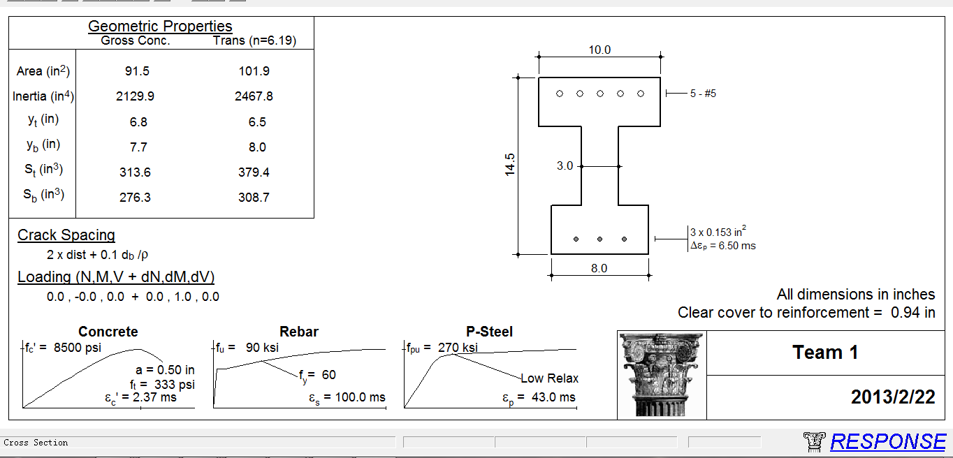
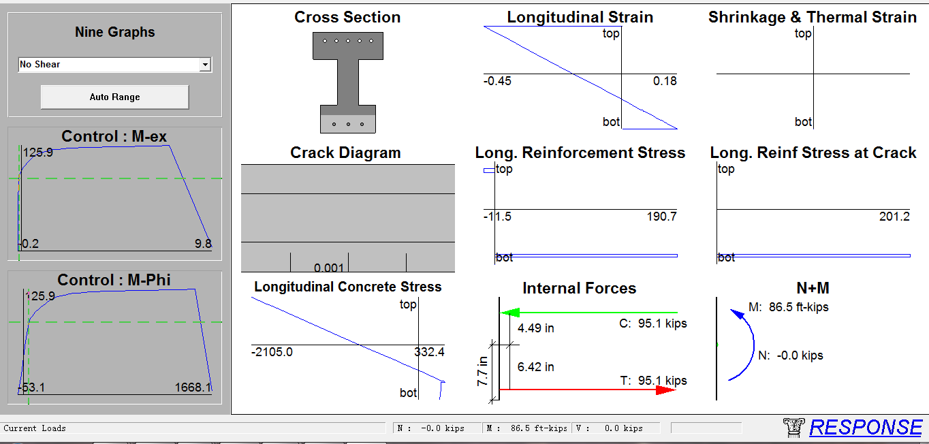
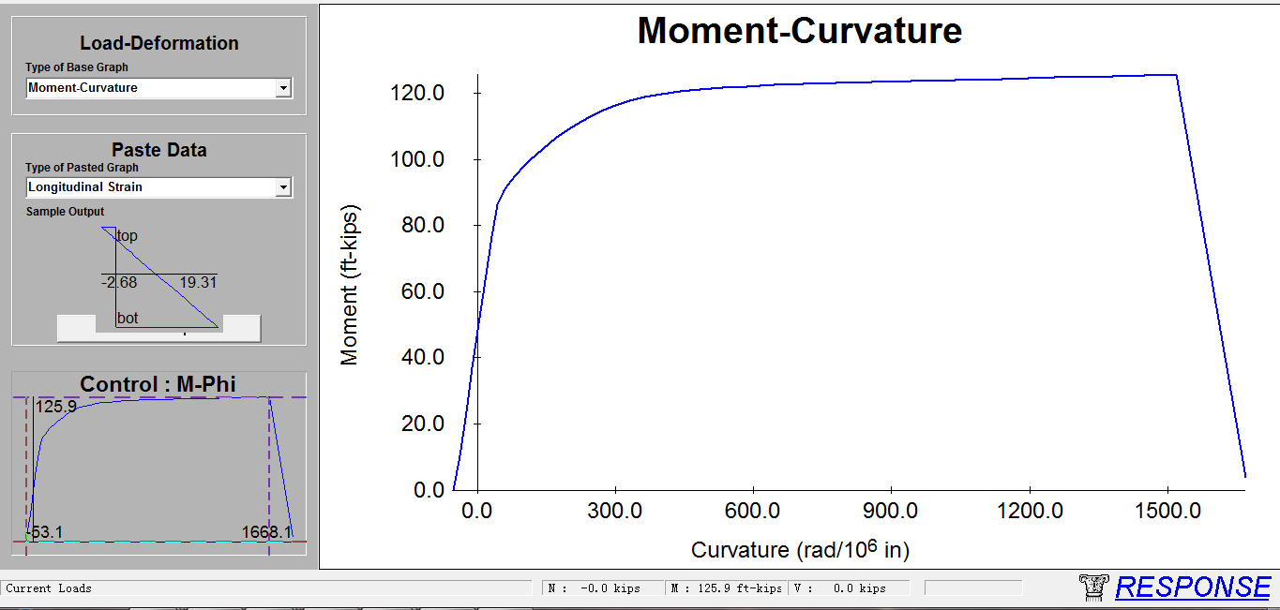

Appendix H — Design Matrix

 |  | Beam 1 |  | Beam 2 |  | Beam 3
Type | Percentile | Measured Value | Grade | Measured Value | Grade | Measured Value | Grade
Cost ($) | 35 | 126.5 | 10 | 132.5 | 9 | 142.5 | 7
EI* (kip-in2) | 30 | 61766449 | 8 | 65442229 | 9 | 68335328 | 7
Weight (lb.) | 35 | 1909.59 | 10 | 1900.06 | 10 | 1990.31 | 6
Total (10) | 100 |  | 9.4 |  | 9.35 |  | 6.65

Appendix I— Test Machine
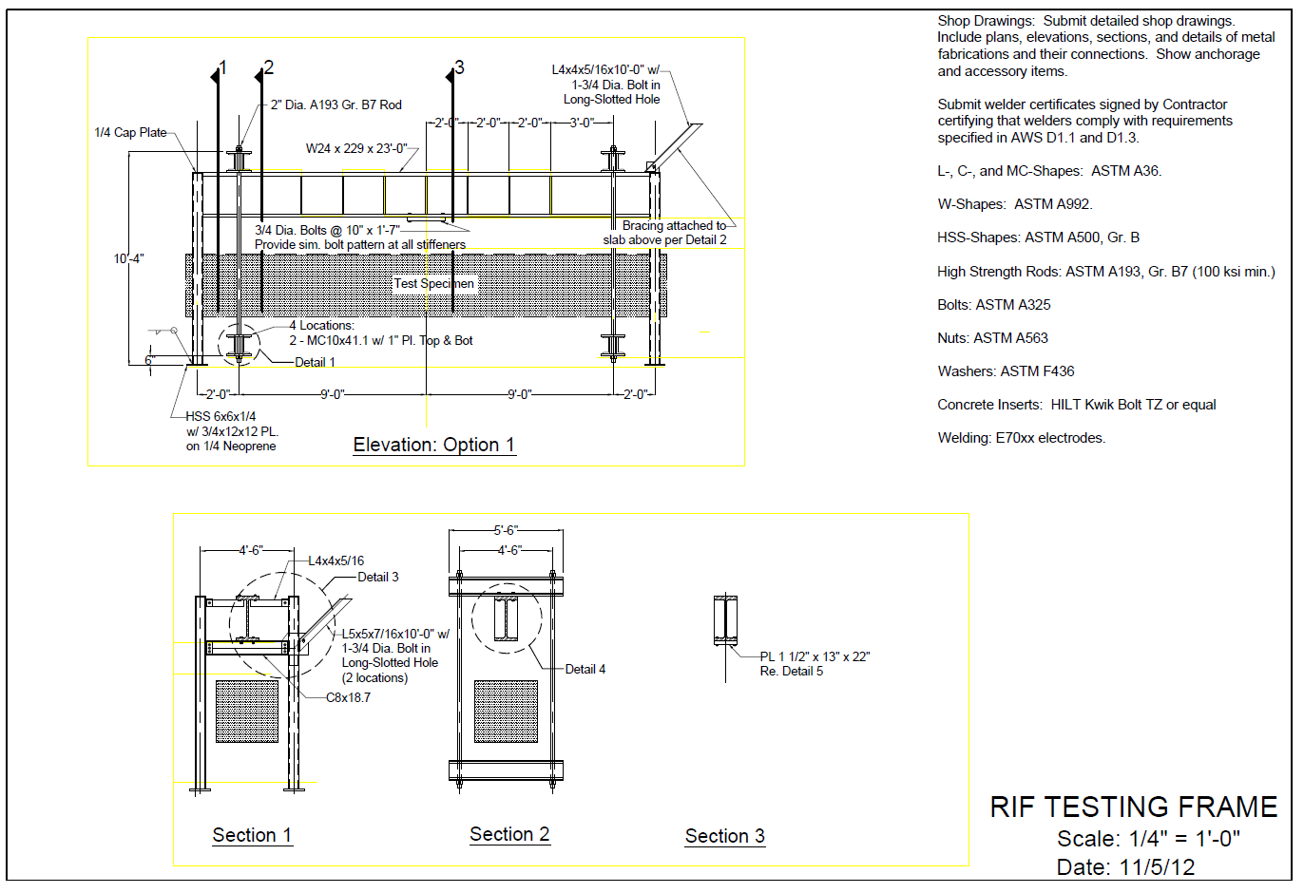

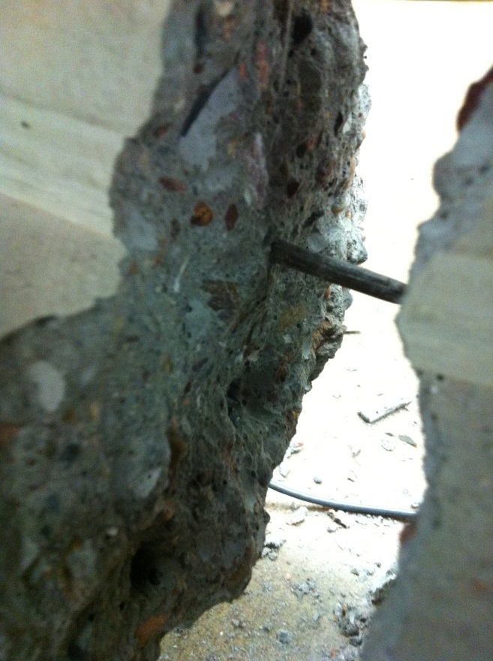
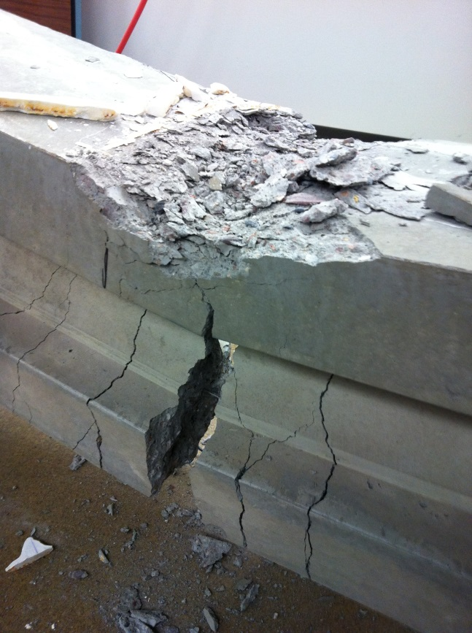
Appendix J— Details of Test

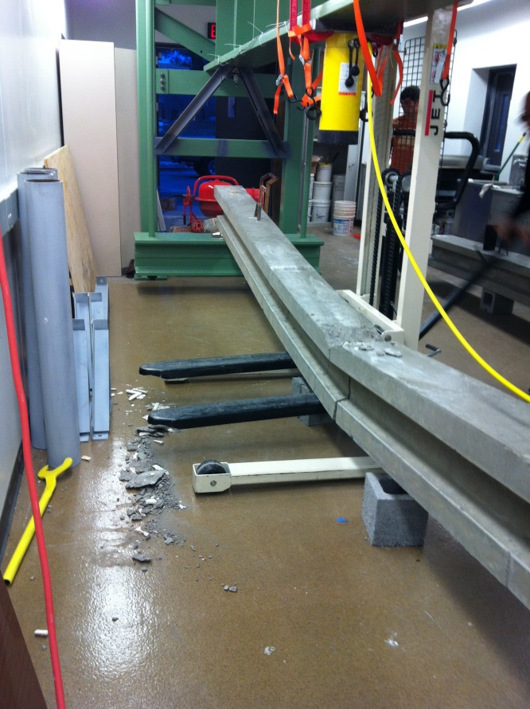
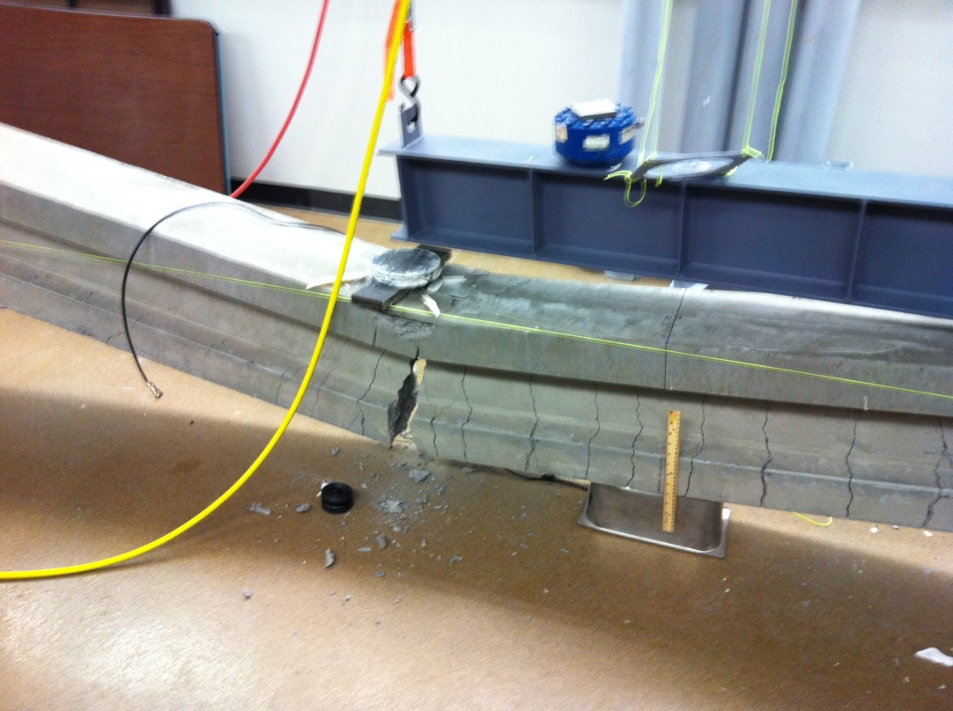

Appendix K— Concrete Mix Report

Appendix L—Final Calculation (Hand Writing)

